Measuring Your Fitness Manual

What you need:
- yardstick
- measuring tape
- stopwatch
- sneakers
- tape

Hypothesis:
How fit do you think you are aerobically? How fit do you think you are anaerobically? How flexible do you think you are?

Aerobic Target Zone:
First, find your aerobic target zone:
- Calculate your Maximum Heart Rate (MHR): 220 - your age = ______
- Calculate the upper range of your aerobic target zone: multiply your MHR by 0.80 = ______
- Calculate the lower range of your aerobic target zone: multiply your MHR by 0.50 = ______
When doing aerobic exercises, your heart rate should be between 50% - 80% of your maximum heart rate:
50 – 60% of MHR corresponds to the “Heart Health Zone”
60 – 70% of MHR corresponds to the “Weight Management Zone”
70 – 80% of MHR corresponds to the “Aerobic Zone”

Cardiovascular Fitness:
Record how long it takes to run or walk a mile on a treadmill or on a predetermined mile-long course: ______minutes.
How does that compare to your reference group below?
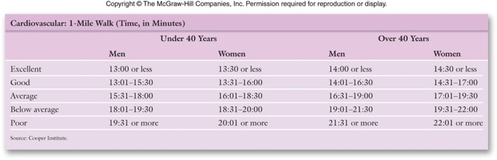

Push-Ups:
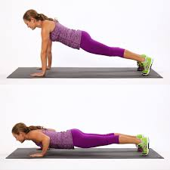
Record the number of push-ups you can do in a row: ______
How does that compare to your reference group below?
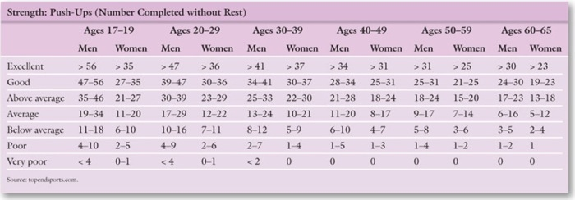

Curl-Ups:
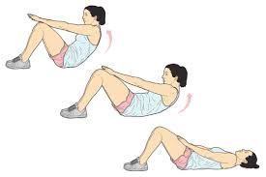
Record how many curl ups you can do in a minute: ______
How does that compare to your reference group below?
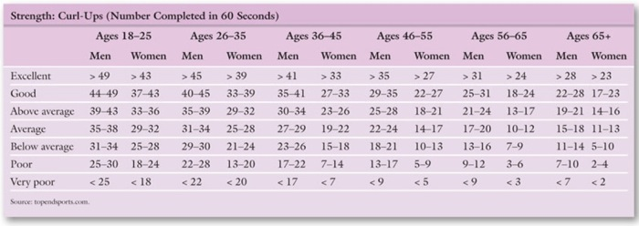

Part V. Sit-and-Reach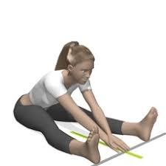
Place a yardstick on the floor and apply a two-foot piece of tape on the floor perpendicular to the yardstick, crossing at the 15 - inch mark. Sit on the floor with your legs extended and the soles of your feet touching the tape at the 15-inch mark, the 0- inch mark facing you. Your feet should be about 12 inches apart. Put one hand on the other, exhale, and very slowly reach forward as far as you can along the yardstick, lowering your head between your arms.
Keep your knees from bending and don't bounce! Note the farthest inch mark you can reach. Don't hurt yourself by reaching further than your body wants to. Relax, then repeat 2 more times.
Record your results: ______
How does that compare to your reference group below?
