To: Classmates (ENGL 315-40)
From: Linda Knapp
Subject: The Rule of Thirds
Date: September 6, 2012

Have you ever taken multiple pictures of the same subject and wonder why some may look better than another? It could be that you’ve been applying the “Rule of Thirds” without even knowing it. When looking at a picture (or even a painting) your eyes naturally tend to go to certain points of interest. These points of interest are not always in the center. Whenever you take pictures, the automatic impulse is to put the subject of the photograph right smack in the middle of the picture. While this isn’t always bad, you may be missing something in the background that can help your subject stand out.
There are three ways to apply the rule of thirds to your photo. The first is to imagine a rectangle made up of nine equal sized boxes, as you’ll see below on the left. The second box below has three equal sized horizontal rectangles. The third box below, on the right, has three equal sized horizontal rectangles.

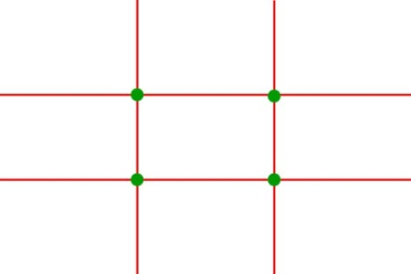
Grids courtesy of photoinf.com

By lining up the subject at the point of intersections, the horizontal line(s) or the vertical line(s) this gives the picture balance. The easiest way to remember the rule of thirds is to avoid the center square in the grid. A couple of questions to ask yourself when lining up your shot:
- What do I want the focus on?
- Where do I put the focus if it’s not in right in the center?

Here are some examples of where you can use the rule of thirds:
- Portraits
- Landscape and nature
- Items with a specific focal point and abstracts
- Breaking the rules

Portraits
One of the easiest ways to apply the rule when taking pictures of people is to line up the eyes with the top horizontal row. By lining them up along the top row, the portrait will give the appearance of being perfectly centered. In the picture below, the gnome’s eyes line up with the top horizontal row on the right.
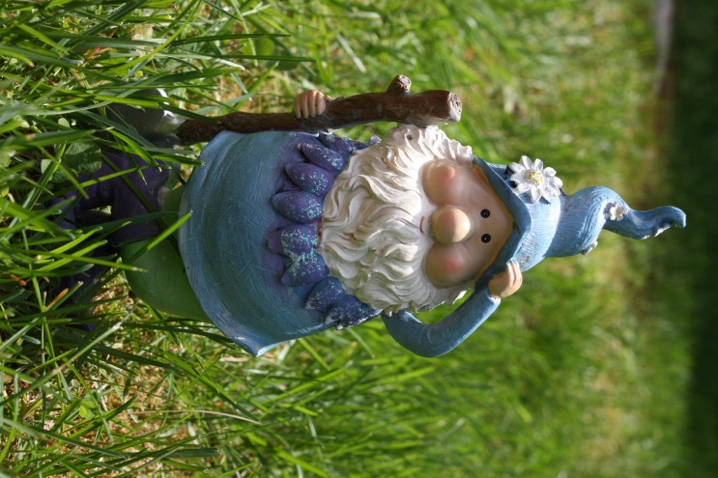

Landscapes and nature
Landscapes and nature are probably the easiest pictures to apply the rule. When taking pictures of landscapes or items in nature, there are a few different ways to apply the rule of thirds depending on what your subject is. If it’s a sunrise, you can line up the horizon with either the top row or the bottom row of the grid.
In the photo below, notice that the horizon lines up with the lower row of the grid:

Figure 1: Sunrise

When taking a picture of a tree or a flower, line it up with an intersection on the grid. In the photo below, the center of the Black-Eyed Susan surrounds the upper right intersection of the grid:
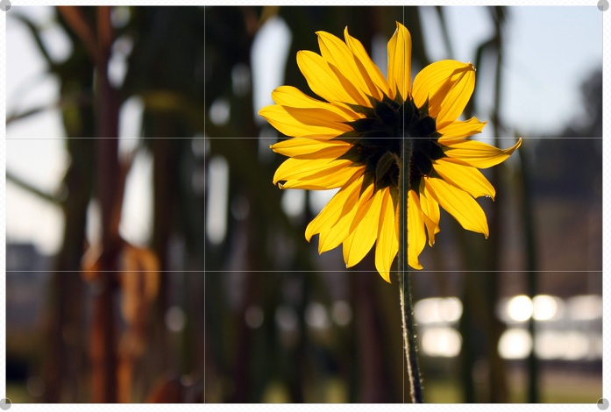
Figure 2: Flower

Items with a specific focal point and abstracts
When taking pictures of something with a specific focal point or an abstract subject, be creative. You can be creative by moving the focal point to the left, right, top, bottom or try it from a different angle. By moving the focal point in such a way, this can create an abstract photo. Instead of taking a picture of the middle of a flower, try taking one from the side, as in the photo below:
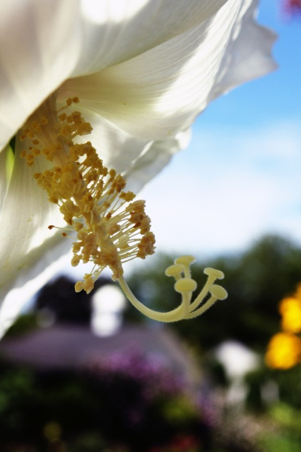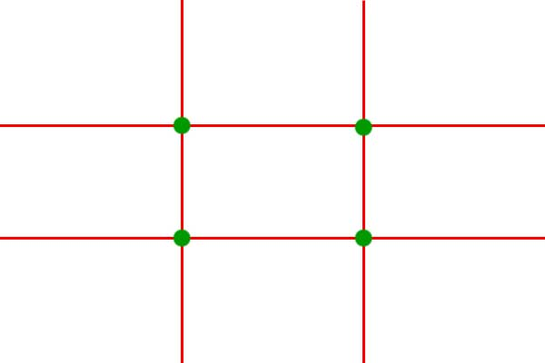
Figure 4: Flower side shot

When trying to apply the rule of thirds, line up the subject with the lines or intersections of the imaginary grid. In the picture above, imagine the grid overlaying the picture. The pistil and stamen line up with the left vertical row and the intersections of the horizontal row. By photographing the flower from the side, this allows the pistil and stamen to become the abstract focus.

Breaking the rules
Last but not certainly not least, rules are meant to be broken! Not every subject will fall neatly into the above categories. What if the subject is a flight of stairs? A fence? A close-up of a fence finial? How would you line it up into a grid? The answer is, you can’t. Be creative!
The photo below is a close-up of a fleur de lis fence finial. There isn’t a particular focal point to lineup in a grid because it is a close up of an object. But this doesn’t make it a bad picture, it makes it creative!
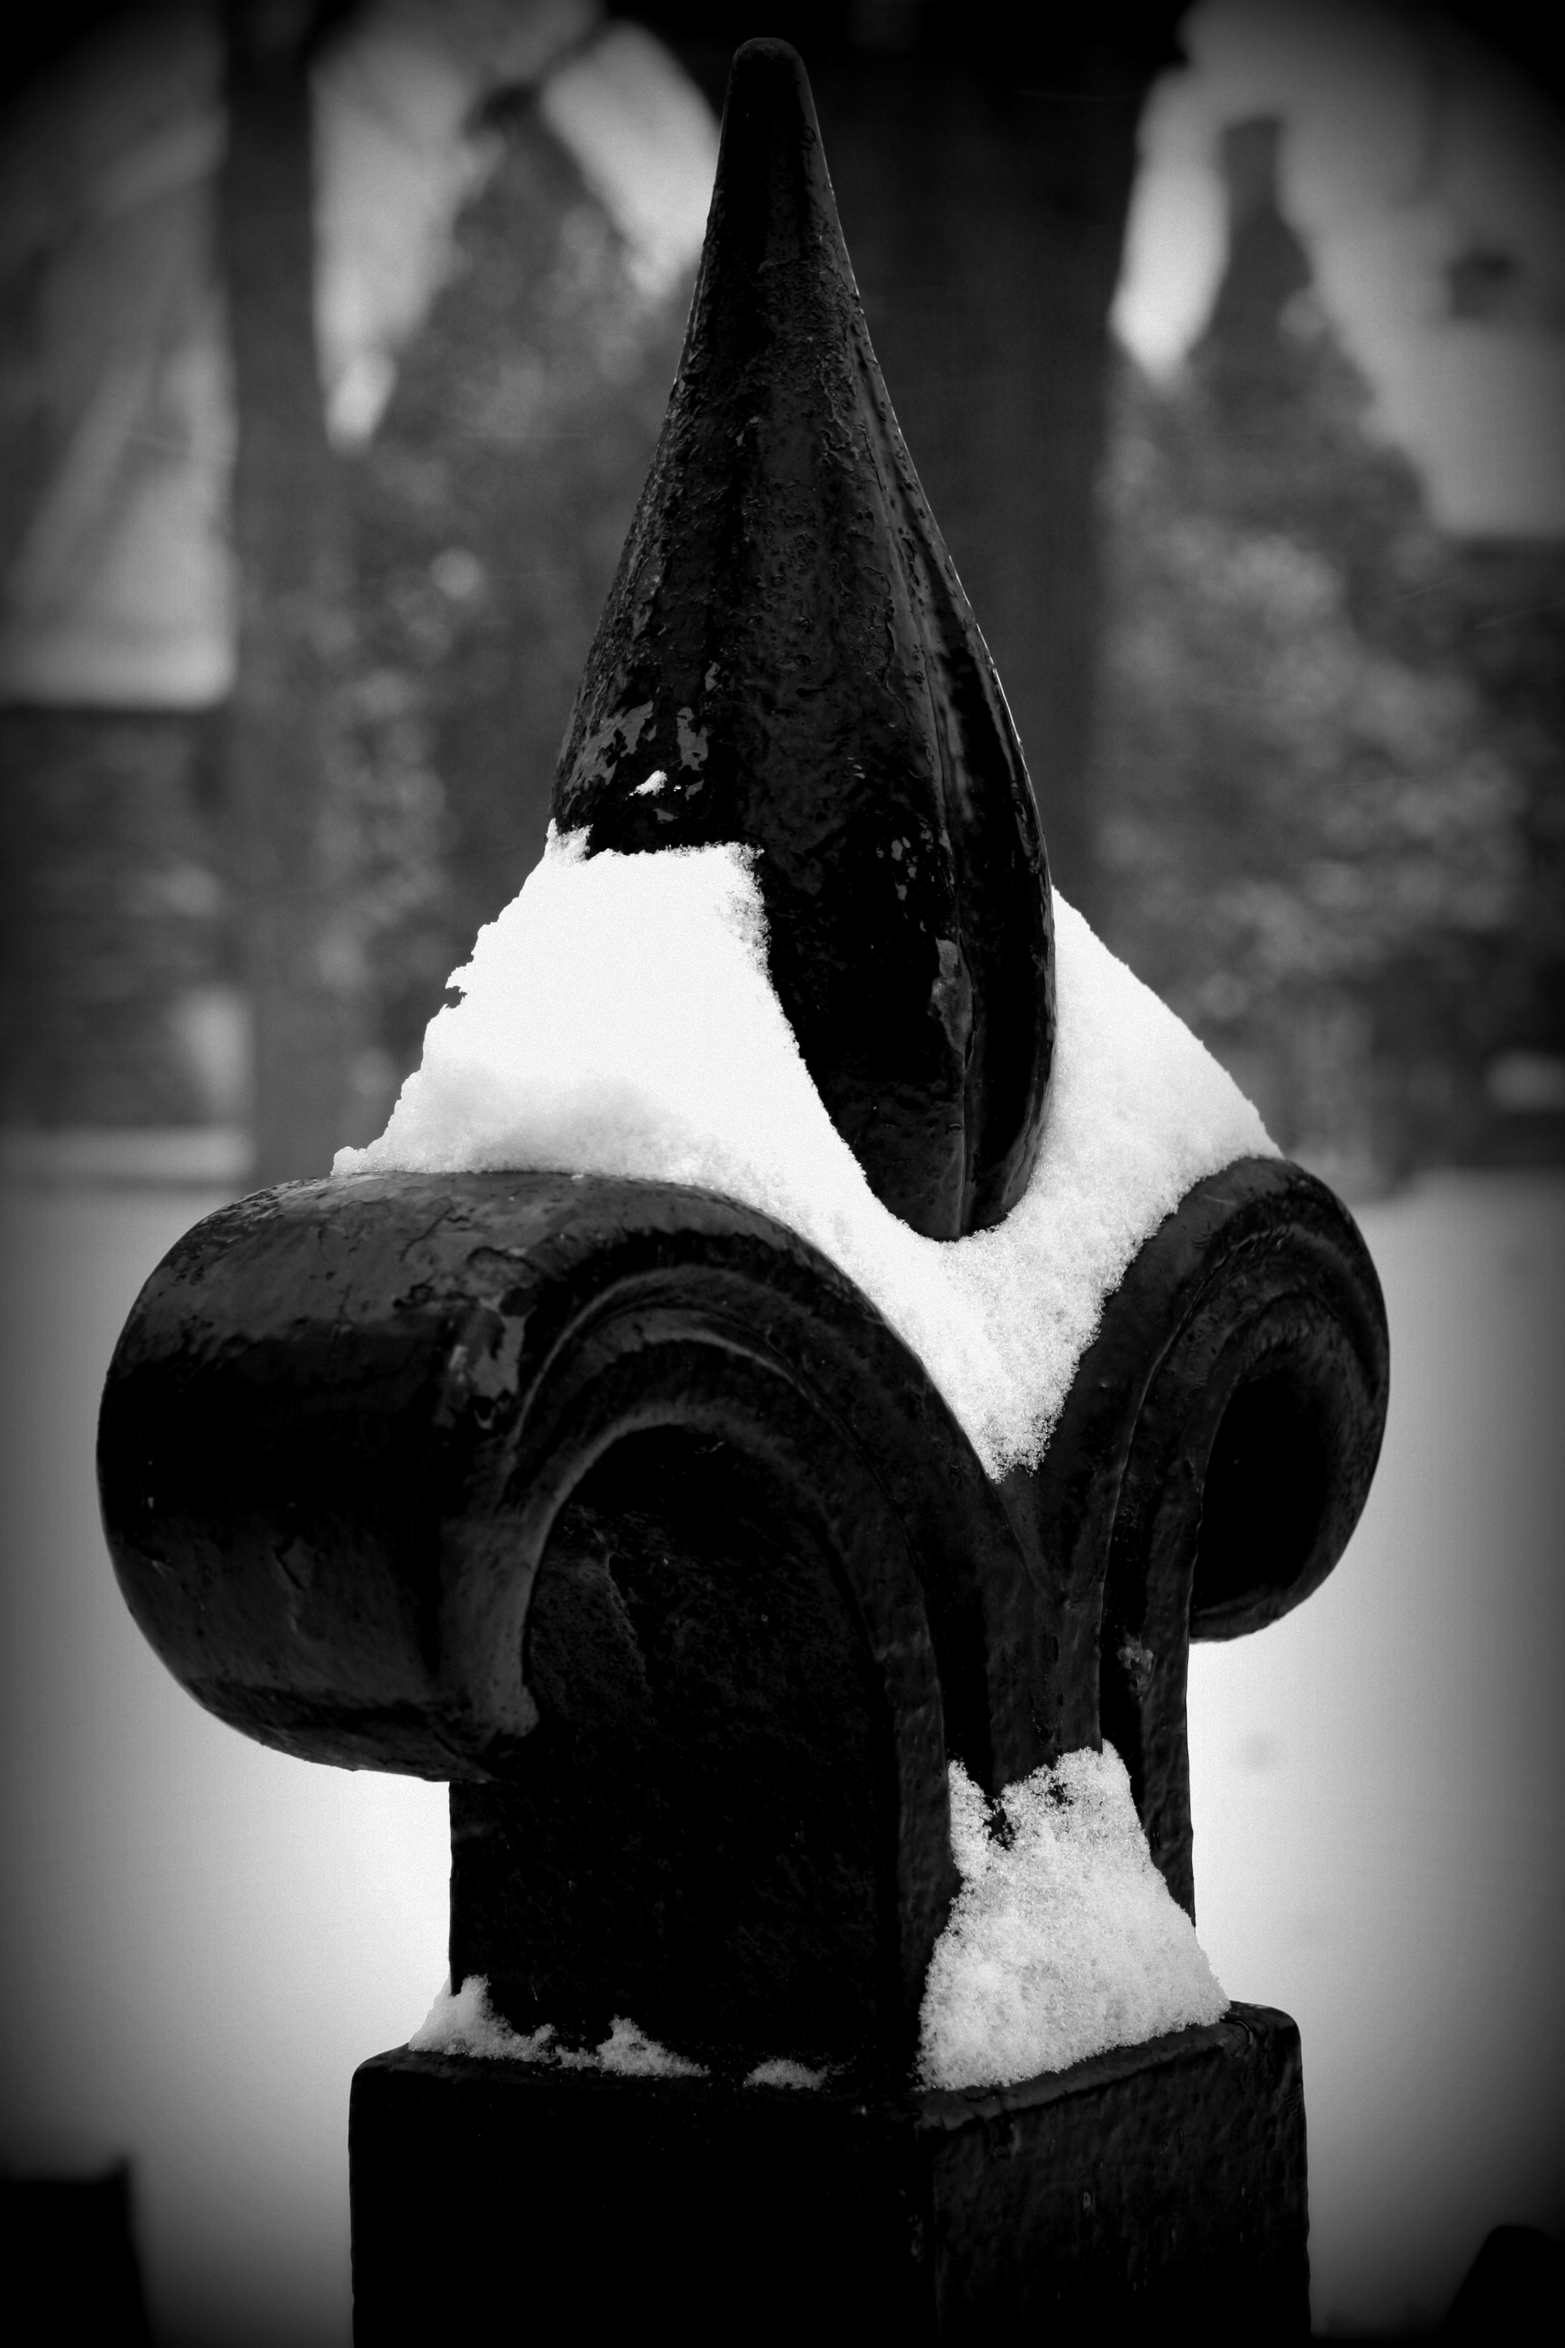
Figure 5: Fence finial

The fleur de lis and the snow are both focal points and are in the direct center of the picture. By taking a close up and centering the object this way, what you’re looking at is a single object with nothing to distract your eye from the subject. You can see the details of the object, such as the lines sculpted into the leaves of the fleur de lis and the snow accentuates these lines. If you were to take a picture of the same object at a distance, the sculpted details disappear. What you would see is a solid piece of iron with the plain shape of a fleur de lis.
Here is a little exercise to test out the “Rule of Thirds.” Next time you take your camera out, take a picture without really thinking any rules, just point and shoot. Then take the same subject and imagine the grid from my explanations above as you look at the subject. Align the subject along any of the imaginary grid intersections or lines (some digital cameras may have this available as a menu option) and see how it comes out. You may be pleasantly surprised at the results.
When looking back at the pictures you take, more often than not, you’ll like the result because something in the background gives you the pop you need to make it special. The “Rule of Thirds” isn’t really a rule, but more of a guideline to use when you’re lining up the subject to take a shot. Look at it as a reminder to take your time and use what is in the background to help accentuate your subject.
Happy Picture Taking!

Sincerely,

Linda Knapp
Part-Time Amateur Photographer.

Works Cited:
"Photo School." Photo School. N.p., n.d. Web. 07 Sept. 2012. <http://photoinf.com/Golden_Mean/Michael_Fodor/Photo_School_-_Rule_of_Thirds.htm>.

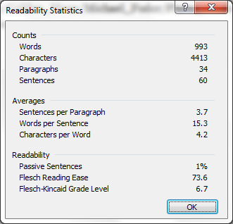
Good job writing in Plain English, Lisa, as demonstrated by your readability statistics (18-22).

