To: ENGL-315-45 Classmates
From: Steven Mance
Subject: How to clean the inside of your computer
Date: March 26, 2014

Keeping a computer clean involves more than just running a virus scan and cleaning up files. Many people forget that the inside of their computer requires routine cleaning as well. Allowing dust to build up inside of your computer can stress the moving parts and greatly restrict the airflow within the tower. Such issues can lead to overheating and a shortened lifespan.
While it may seem like a scary task, cleaning the inside of a computer tower is quite simple as long as the cleaner follows the appropriate steps. I have been a computer enthusiast since I was a child, which means I have cleaned my fair share of computers. By sharing my knowledge on the subject, I hope I can inspire my classmates to take initiative and clean their computers.
The task of cleaning your computer can be broken down into three different sections:

- Required equipment
- Safety considerations
- Cleaning

Required equipment

There are only a few special tools needed for the task of cleaning a computer:

- Screwdriver (dependent on type of screws on tower)
- Can of compressed air (for cleaning inside of computer)
- Household vacuum (optional, for cleaning work area)

Safety considerations

Before you start removing dust, it is important to consider safety first.

- You must disconnect the computer from its power source by switching off the power supply or unplugging it. As shown below, the power supply will be located at either the top or the bottom on the back of the tower:
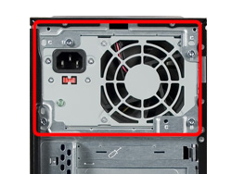
Power supply
- Computer hardware is sensitive to static electricity—avoid directly touching parts without grounding yourself first. If your tower is metal, ground yourself by touching the outside of the tower periodically while cleaning.
- Take precautions if you are sensitive to dust. One option is to clean your computer on a hard surface outside to avoid releasing dust into your home.
- Never use a regular household vacuum to clean a computer—it creates a large static buildup that can potentially damage the hardware.
- Avoid disconnecting inside hardware if you are inexperienced with computers.

Cleaning

Now it is time to begin the cleaning process. Follow these steps to ensure a thorough cleaning:

- Unplug all connected devices and move the computer to the work area. Note: this area will likely get very dusty. Rather than work on a carpet, consider working on a hard surface to make cleanup easier.
- Use the screwdriver to remove the screws holding the side panel on the tower. The design of the screws varies for different computer towers. Generally, only the screws along the edges of the tower will need removal.

Please refer to the red arrows in the following figure for a general screw removal guideline:

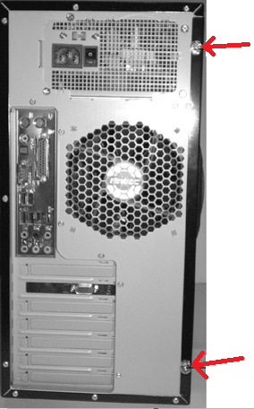
Location of screws
After removing all screws, slide off the side panel to expose the hardware.
- Examine the hardware within the tower and locate dusty areas. It is important to remove dust from all areas; however, it tends to accumulate on moving parts such as fans. Refer to the yellow arrows in the following figure for the common locations of dust buildup—two regular fans, plus the power supply fan and the processor fan:

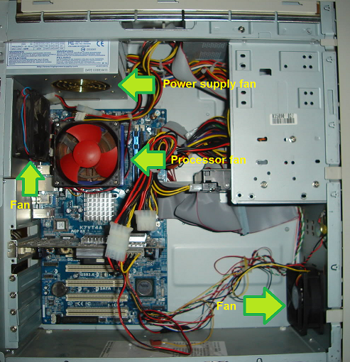
Locations of common dust buildup
- Begin using the compressed air can to blow away dust. Hold the can upright and at a moderate distance from the hardware. Some sources suggest starting at the top of the tower and working your way down.
- Spend extra time removing dust from moving parts such as fans. Be sure to blow all dust off blades and the center mechanism. Do not neglect the fan within the power supply – blow compressed air into the vents to push dust out.
- Perform a final inspection to ensure that little to no dust remains.
- Slide the side panel back into place and reattach the screws. Relocate the computer back to its original location and reconnect the devices.
- There will likely be a pile of dust bunnies surrounding the work area. If needed, use a vacuum to clean the area and remove all dust.
- Enjoy your clean computer!

As you can see, cleaning the inside of your computer is much easier than it sounds. Setting aside time to clean your computer periodically will help to ensure that it is running smoothly which will also increase its lifespan.

So, what are you waiting for? Crack open that tower!

Sincerely,

Steven Mance
Computer Enthusiast and Digital Forensics Major

