To: Classmates of ENGL-315
From: Linda Karol
Subject: How to choose a cloth diaper
Date: January 25, 2013

As a mother of two, I have spent the last six years caring for children. Naturally, a large part of that care involved diapering babies and toddlers countless times a day. Although most people see the diapering process as a necessary evil, many don’t realize that there are far more options than picking up a pack of Huggies at the supermarket.
You may have heard of cloth diapering before. Even those of us who don’t have children may have heard the practice mentioned by co-workers or friends. It’s touted as a healthier and more environmentally sound way to diaper a child, and its popularity is growing. If it is so wonderful, then why isn’t everyone rushing out to buy cloth diapers? The truth is that there are just so many types of diapers out there that it is often overwhelming. Even the most committed expectant parent or baby shower attendee may give up in the face of all that Velcro, elastic, buttons, and snaps.
To combat this information overload, this report will provide simple explanations of the four most common types of cloth diapers available on the market today, including:
- Covers
- Pre-folded Diapers
- Fitted Diapers
- All-in-Ones

Covers
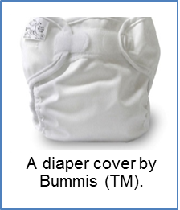
The first type of cloth diaper I will discuss is a cover, as pictured below. Just like the outer portion of a disposable diaper, a cloth diaper cover is water-resistant, and the elastic around the legs serves to prevent any fluid from leaking on to the baby’s clothes. The inside of the cover is most commonly coated with polyurethane laminate, which makes it slick and waterproof. Whereas a disposable diaper has tape or Velcro tabs, cloth diapers covers have either snaps or Velcro tabs to fasten them. You must then place an absorbent cloth inside of the cover.
Velcro Tab
Velcro Tab
Pros:
Elastic Leg
- Easy to launder
- Quick to dry
- Easily wiped down for re-use
- Inexpensive
Cons:
- Requires an inner liner, which adds another step to diapering and an additional purchase
- May cause an allergic reaction in babies sensitive to polyurethane laminate

Pre-folded Diapers
The first option for adding an absorbent layer inside your cloth diaper cover is a pre-folded diaper. This serves the same function as the chemical beads present inside disposable diapers by absorbing liquid. A pre-fold is a flat, quilted piece of cotton that you fold and place inside the diaper cover. The easiest way is to simply fold it over and place it inside the cover like this:
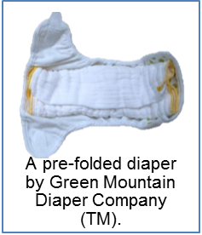
Pre-folded diaper
Diaper Cover
Another option is to fold it around the baby and fasten it with a stretchy clip called a Snappi:
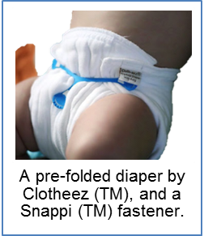
Pre-Folded Diaper
Snappi Fastener
Both ways work well, but fastening the pre-fold around the baby tends to prevent more leaks.
Pros:
- Easy to launder
- Dries quickly
- Prevents bacterial build up with thin and breathable material
- Inexpensive
Cons:
- Folding takes time and may take patience to learn
- Absorbs less liquid due to thin material
- Requires the purchase of a fastener for better protection

Fitted Diapers
The second option for adding an absorbent lining is a fitted diaper, as pictured below. This is several pieces of absorbent cotton, hemp, or bamboo sewn together in a diaper shape. It fits neatly inside the diaper cover and often has plastic snaps or Velcro to fasten it around the baby.
Pros:
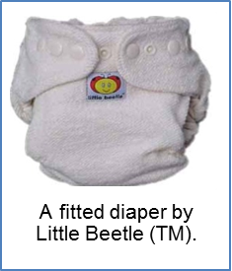
- Easy to launder
- Fast and simple to use
Velcro Tab
- Superior leak protection
Cons:
Elastic Leg
- Significantly more expensive than pre-folds
- Susceptible to bacteria issues due to thick material

All-In-Ones
The direct equivalent to a disposable diaper, an all-in-one diaper, pictured below, is exactly what it sounds like— it has both a waterproof outer layer and an absorbent inner layer. It is all one piece and can be put on, laundered, and dried very quickly and simply.
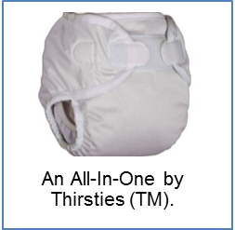
Waterproof Outer Layer
Absorbent Inner Layer

Pros:
- Very easy and efficient to put on
- Allows for swift diapering, which is good for squirmy babies and toddlers
- Minimal learning curve helps daycares or babysitters who have no cloth diaper experience
Cons:
- Relatively expensive
- More prone to leakage than covers
- Takes longer to dry and requires a more thorough washing
- Harbors bacteria if not properly cleaned

When choosing a cloth diaper, it is important to take into consideration the preferences of the people who will most often be diapering the child. If the individual has a strict budget or wants a diaper that is less susceptible to bacteria, he or she may want to take the time to learn how to use a pre-folded diaper with a diaper cover. For those who can afford it and want a diaper that is efficient and has no learning curve, an all-in-one diaper is an excellent choice.
My personal favorite, however, is a combination of a fitted diaper and a diaper cover. In my years of diapering, I found that using a fitted diaper under a cloth diaper cover, both with Velcro tabs, was a method that was easy to learn and rarely resulted in leaks. Whichever method you choose, you will be glad to know that your choice supports both the health of the environment and the health of the child.

Happy Diapering!
Linda Karol
Mother of Two

