No surprise here…I went with the “Installing RAM” sample report as I am an IT guy. I found the report very readable, both in terms of its readability statistics and its use of Plain Language.

One readability statistic
Here are the readability stats as per Word 2016:
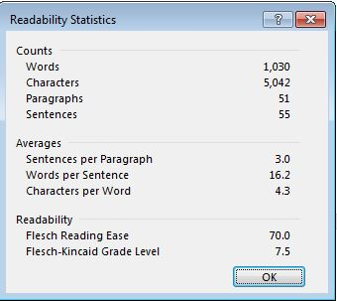
The Flesch Reading Ease statistic shows that this is an easily digestible report that falls within the standard averages between 60-70. I looked at the chart in the link to readability terminology in the directions, above, and I found that the report leans more toward the higher end of the average spectrum, which means that most adults would find it easy reading. The higher the Flesche Reading Ease score, the easier it is to read!

One feature of Plain Language
As for the “Plain Language” breakdown I see the following:
Step 3: Write the content in plain language
Often times in technical documents the language used can be a bit overwhelming if you are not familiar with the terminology. I feel the author did a good job at describing the process in layman’s terms when possible. Technical language is required to a certain extent to describe the parts, but I felt the author did a good job particularly describing the differences between a 32bit operating system and a 64bit one. She kept it simple by not diving down into the technical differences that would have quickly lost the average reader.

