How to View Organizational Charts in Workday

In the top right search bar type in “Org Chart” and select the Org Chart task from the results.

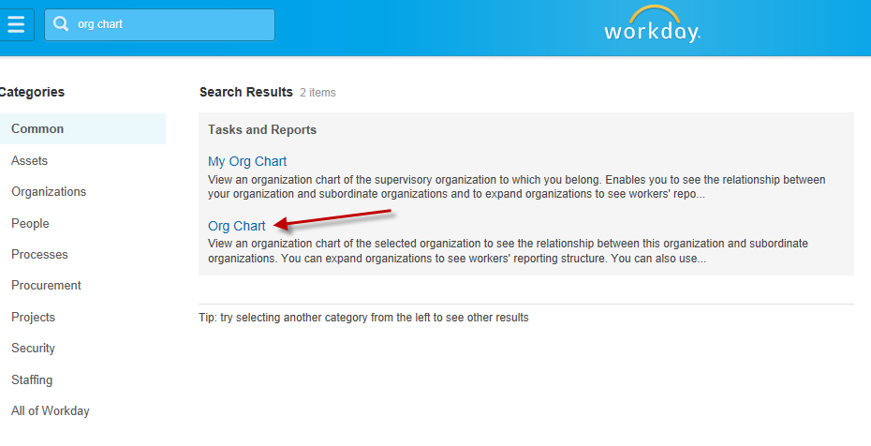

Select the organization you want included in the org charts and click OK. If you want the entire college you can search for Finney and select the President’s Office

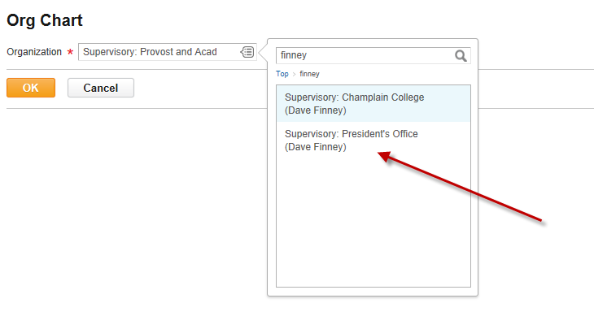
The org chart will generate. You now have the ability to expand by department or print the entire org chart.

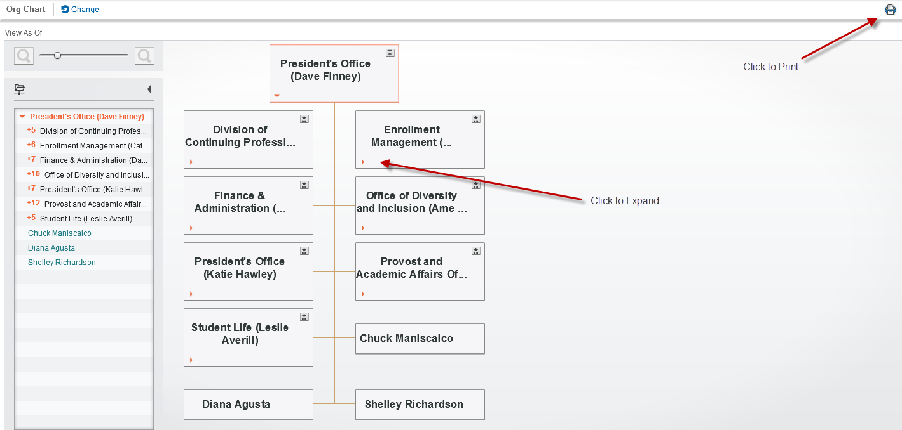

If you choose to print, Workday will ask you to specify the Levels (how many management levels you want to include) as well as the Text Size. After completing this you can click OK and the PDF version will generate.

